Artificial Intelligence: Machine Learning, Deep Learning, Generative AI, and AI Agents

1. Introduction to Artificial Intelligence
Artificial Intelligence (AI) is a field of computer science focused on developing systems that can perform tasks that normally require human intelligence. These tasks include understanding language, recognizing images, solving problems, making predictions, learning from experience, and making decisions.
AI systems are used in healthcare, education, finance, manufacturing, transportation, agriculture, and software development. For example, a hospital may use AI to analyze medical images, a bank may use machine learning to detect fraudulent transactions, and an online shopping platform may use recommendation systems to suggest products to customers.
Artificial Intelligence includes several important areas, such as Machine Learning, Deep Learning, Generative AI, Natural Language Processing, Computer Vision, and Agentic AI. Although these technologies are related, they solve different types of problems.
Machine Learning enables systems to learn patterns from data. Deep Learning uses neural networks with multiple layers to learn complex patterns. Generative AI creates new content, including text, images, audio, and code. Agentic AI systems can use models, tools, memory, and planning to complete tasks through multiple steps.
Understanding the relationship between these technologies is important for developing modern intelligent applications.

2. Machine Learning

2.1 Definition of Machine Learning
Machine Learning (ML) is a branch of Artificial Intelligence that enables computers to learn patterns from data and use those patterns to make predictions or decisions without requiring every rule to be explicitly programmed.
Traditional software generally follows predefined instructions. In contrast, a machine learning model learns relationships from training examples and applies those relationships to previously unseen data.
For example, an email spam detector can learn from thousands of emails labeled as spam or legitimate. After training, the model can estimate whether a new email is likely to be spam.
Machine Learning is widely used in fraud detection, sales forecasting, customer segmentation, disease-risk prediction, recommendation systems, and predictive maintenance.

2.2 How Machine Learning Works
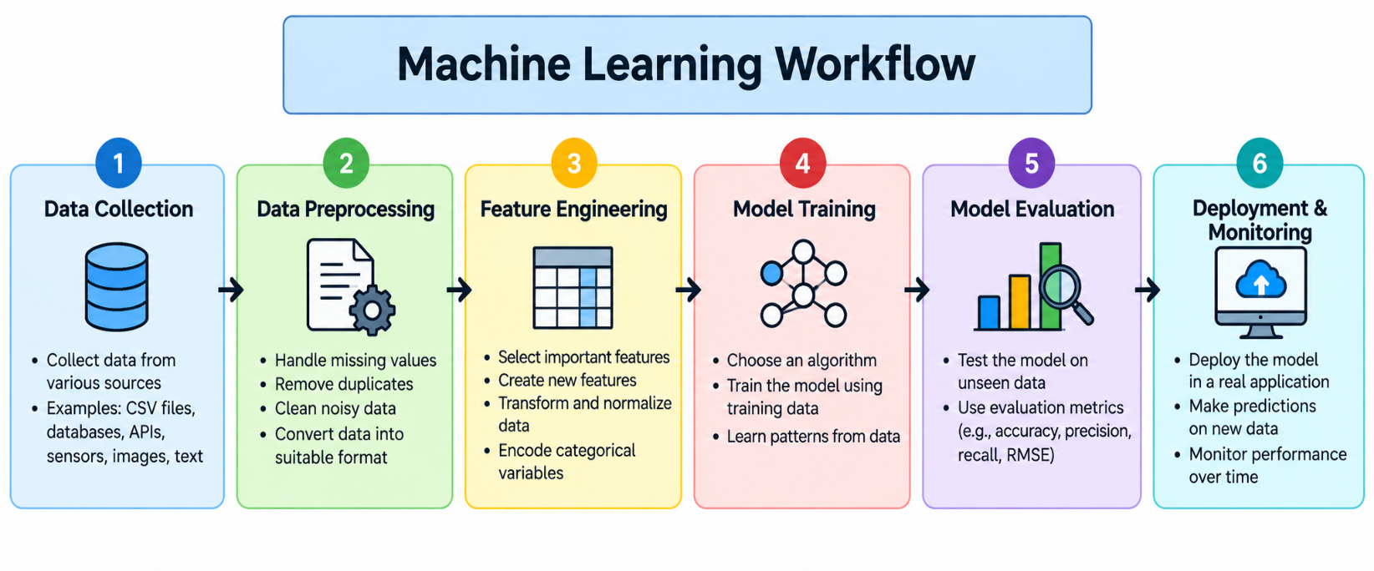

A typical machine learning workflow begins with collecting relevant data. The data is then cleaned and prepared to remove errors, handle missing values, and convert information into a suitable format.
Next, relevant features are selected or created. A machine learning algorithm uses the prepared training data to learn patterns and produce a model.
The model is evaluated using data that was not used during training. Evaluation metrics help determine whether the model performs well enough for its intended purpose.
After evaluation, the model can be deployed into an application. Its predictions should be monitored because changes in real-world data may reduce performance over time.
The major steps are data collection, data preprocessing, feature engineering, model training, model evaluation, deployment, and monitoring.

2.3 Types of Machine Learning
Machine Learning is commonly divided into supervised learning, unsupervised learning, semi-supervised learning, and reinforcement learning.
Supervised Learning: The model learns from labeled examples containing inputs and their correct outputs. It is commonly used for classification and regression. For example, a model may predict house prices using historical property data.
Unsupervised Learning: The model discovers patterns in data without predefined target labels. It can be used for clustering customers, identifying unusual behavior, and exploring datasets. K-Means is a common clustering algorithm.
Semi-Supervised Learning: The model learns using a small amount of labeled data and a larger amount of unlabeled data. This can be useful when manually labeling data is expensive.
Reinforcement Learning: An agent learns by interacting with an environment and receiving rewards or penalties. It attempts to develop a strategy that maximizes long-term reward. Applications include robotics, game-playing systems, and certain control problems.

2.4 Common Machine Learning Algorithms
Linear Regression predicts continuous numerical values by modeling relationships between input variables and a target. It can be used to estimate property prices, sales revenue, or product demand.
Logistic Regression is commonly used for classification. For example, it can estimate whether a customer is likely to cancel a subscription.
Decision Trees make predictions using a sequence of feature-based decisions. Their structure is relatively easy to interpret, making them useful for many classification and regression problems.
Random Forest combines predictions from multiple decision trees. This ensemble approach can improve predictive performance and reduce some of the limitations of an individual tree.
Support Vector Machines identify decision boundaries that separate classes or support regression tasks. Their effectiveness depends on the dataset, kernel choice, and parameter settings.
K-Nearest Neighbors predicts outcomes using nearby training examples. It can be applied to classification and regression, although prediction may become expensive for large datasets.
K-Means groups observations into a specified number of clusters. Businesses may use it to identify customer groups with similar purchasing behavior.

2.5 Machine Learning Applications
In healthcare, ML can assist with risk prediction, patient prioritization, and analysis of clinical data. In finance, it can identify suspicious transaction patterns and estimate credit risk.
In retail, machine learning can forecast demand, recommend products, and estimate customer churn. In manufacturing, predictive maintenance models can identify patterns that indicate possible equipment failure.
In agriculture, ML can support crop disease detection, yield estimation, and irrigation planning. In transportation, it can help forecast traffic and estimate delivery times.
Machine learning predictions are not automatically correct. Their reliability depends on the quality of training data, the relevance of selected features, model design, and evaluation methods.

3. Deep Learning

3.1 Definition of Deep Learning
Deep Learning is a specialized branch of Machine Learning that uses neural networks with multiple computational layers to learn complex representations from data.
A neural network consists of interconnected units called neurons. These neurons receive inputs, apply mathematical operations and activation functions, and pass information through the network.
During training, the model adjusts its parameters to reduce prediction errors. This process typically involves a loss function, backpropagation, and an optimization algorithm such as stochastic gradient descent or Adam.
Deep Learning is particularly useful for complex data such as images, speech, video, and natural language. It often requires substantial training data and computational resources, although smaller models can also be effective for specific tasks.

3.2 Structure of a Neural Network
A basic neural network contains an input layer, one or more hidden layers, and an output layer.
The input layer receives features or representations of the input data. Hidden layers transform these inputs into increasingly useful representations. The output layer produces a prediction, classification, probability, or other task-specific result.
For example, an image classifier may receive pixel values as input and produce probabilities for categories such as cat, dog, or car.
During training, the network compares its prediction with the expected output. The loss function measures the error, and backpropagation calculates gradients that help update the model's parameters.

3.3 Common Deep Learning Architectures
Artificial Neural Networks (ANNs): General-purpose neural networks commonly used for structured data and a wide variety of prediction tasks.
Convolutional Neural Networks (CNNs): Architectures designed to process spatial patterns. They are widely used in image classification, object detection, and image segmentation.
Recurrent Neural Networks (RNNs): Networks designed to process sequential information. Traditional RNNs can struggle with long-range dependencies, which motivated the development of architectures such as LSTMs and GRUs.
Long Short-Term Memory Networks (LSTMs): Recurrent networks with gating mechanisms that help preserve information over longer sequences. They have been used in speech recognition, time-series analysis, and language processing.
Transformers: Architectures that use attention mechanisms to model relationships between elements in a sequence. Transformers are central to many modern language models and are also used in vision, audio, and multimodal applications.

3.4 Machine Learning vs. Deep Learning
Machine Learning includes many approaches, such as linear models, decision trees, and clustering algorithms. Deep Learning focuses on multilayer neural networks.
Traditional ML models can work well with structured datasets and carefully engineered features. Deep Learning often excels when learning complex representations from large collections of images, audio, text, or other high-dimensional data.
However, Deep Learning is not always the best option. A simpler model may be faster, easier to explain, and more appropriate when training data is limited.

4. Generative Artificial Intelligence

4.1 Definition of Generative AI
Generative Artificial Intelligence refers to AI systems that generate new content based on patterns learned from training data or information provided at inference time.
Generative AI can create text, images, audio, video, computer code, summaries, and structured outputs. Examples include writing assistants, image-generation systems, conversational assistants, code-generation tools, and document summarization applications.
Unlike a conventional classifier that assigns a label to an input, a generative model produces a sequence or other form of content. For example, a classifier may identify an image as a cat, while an image-generation model may create a new picture of a cat from a text description.
Generative AI outputs are not guaranteed to be correct. Models can produce fabricated facts, incorrect calculations, inconsistent explanations, or content that does not follow the user's instructions.

4.2 How Generative AI Works
Generative AI models learn statistical patterns and representations from training data. During generation, they use a prompt or other input to produce content according to the model's learned behavior.
Many language models generate text by predicting the next token based on preceding context. A token may represent a word, part of a word, punctuation, or another unit of text.
Transformer-based language models use attention mechanisms to process relationships between tokens. Their learned parameters represent patterns acquired during training.
Some models are adapted to follow instructions, answer questions, use tools, or generate structured outputs. Model behavior also depends on the prompt, available context, decoding settings, and any external information provided to the system.

4.3 Large Language Models
A Large Language Model (LLM) is a model trained to process and generate language. Many modern LLMs use transformer architectures.
LLMs can answer questions, summarize documents, translate text, generate code, extract information, and assist with reasoning tasks. Their performance depends on the model, task, input quality, and available context.
A model's knowledge may be incomplete or outdated. It may also misinterpret ambiguous questions or produce convincing but incorrect statements.
For applications that depend on specific documents or current business information, external retrieval can provide relevant evidence to the model.

4.4 Retrieval-Augmented Generation (RAG)
Retrieval-Augmented Generation combines information retrieval with generative AI. Instead of relying exclusively on the model's internal learned knowledge, a RAG application retrieves relevant information from an external knowledge source and supplies it as context.
A typical RAG pipeline begins by loading documents such as PDFs, text files, Word documents, and web pages. The documents are divided into smaller chunks, which are converted into vector embeddings and stored in a vector database or another retrieval index.
When a user asks a question, the system retrieves relevant chunks using semantic search, keyword search, or a hybrid retrieval strategy. The retrieved information is then included in the prompt sent to the language model.
The model generates an answer based on the question and retrieved context. The application may also return citations, document names, page numbers, or chunk identifiers to help users verify the answer.
RAG is useful for internal knowledge assistants, customer support, technical documentation, policy search, and document analysis.

4.5 Benefits and Limitations of RAG
RAG can help an application answer questions about private documents without requiring the language model to be retrained whenever the document collection changes. It can also improve traceability when the application provides reliable citations.
However, RAG does not eliminate hallucinations. If retrieval returns irrelevant information, misses important sections, or supplies conflicting evidence, the generated answer may be incorrect.
RAG quality depends on document extraction, chunking, embeddings, retrieval ranking, context construction, and generation. Scanned documents may require OCR, while tables and images may require specialized extraction or multimodal processing.
Evaluation should consider retrieval relevance, answer correctness, citation accuracy, response latency, and the system's ability to recognize when the available information is insufficient.

5. AI Agents and Agentic AI

5.1 Definition of an AI Agent
An AI agent is a system that receives information about a task or environment and takes actions to achieve a goal. Depending on its design, it may use a language model, external tools, memory, planning, and feedback from the results of its actions.
A basic chatbot usually responds to messages. An AI agent can go further by deciding which steps are needed, calling an appropriate tool, observing the result, and continuing until it reaches a stopping condition.
For example, a travel-planning agent might collect destination preferences, search for transportation options, compare hotel information, and prepare an itinerary. Actions such as making a booking or spending money should require appropriate authorization.
An agent is not necessarily autonomous in every situation. Its level of autonomy depends on its permissions, workflow design, available tools, and human approval requirements.

5.2 Core Components of an AI Agent
Goal: Defines the task the agent is expected to complete.
Language Model or Policy: Helps the agent interpret requests, reason about possible steps, and select actions.
Tools: Allow the agent to interact with external systems. Examples include search tools, calculators, databases, APIs, and code execution environments.
Memory: Stores relevant information across steps or interactions. Short-term memory may hold the current task context, while persistent memory may store selected information for future use.
Planning: Breaks a complex task into smaller steps and determines an appropriate sequence of actions.
Observation and Feedback: Provide information about the results of tool calls or environmental changes. The agent can use this information to adjust its next action.
Guardrails and Permissions: Restrict unsafe or unauthorized actions and define when human approval is required.

5.3 How an AI Agent Works
An AI agent begins by receiving a goal from the user or another system. It interprets the request and determines whether it can respond directly or needs additional information.
If tools are required, the agent selects an appropriate action and sends a request to the relevant tool. The tool returns a result, which the agent examines before deciding what to do next.
This process can repeat several times. The agent may revise its plan when new information becomes available or when a tool fails.
The agent stops when the goal is completed, a stopping condition is reached, or further action is not possible or appropriate. Depending on the application, it may then return a final response or ask the user for clarification.

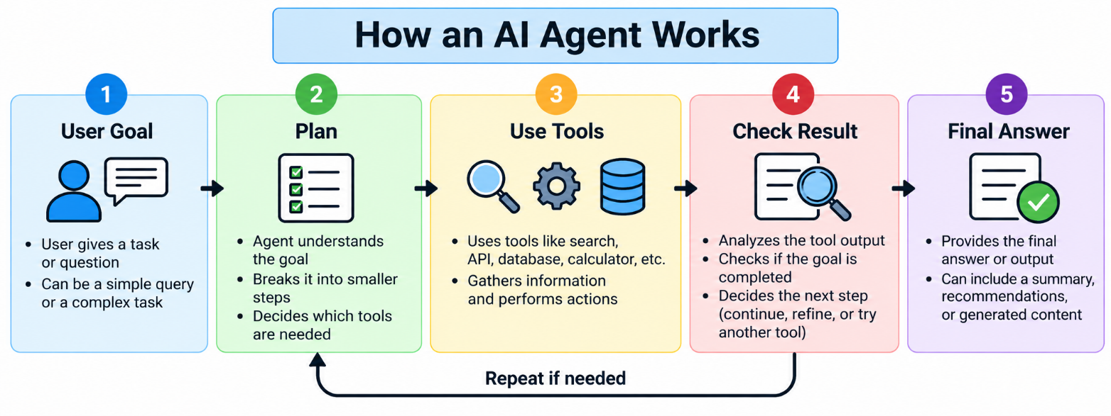

5.4 Single-Agent and Multi-Agent Systems
A single-agent system uses one primary agent to manage a task. It is often simpler to develop, test, monitor, and maintain.
A multi-agent system uses multiple agents with different roles or areas of responsibility. For example, a research workflow might use one agent to gather information, another to analyze the findings, and a third to review the final report.
Multi-agent systems can help separate complex tasks into manageable responsibilities. However, they may also introduce additional latency, cost, coordination problems, duplicated work, and inconsistent outputs.
Using multiple agents is not automatically better than using one. The architecture should be selected according to the complexity of the task and the measurable benefits of specialization.

6. Comparison of AI Technologies
The following table summarizes the primary differences between Machine Learning, Deep Learning, Generative AI, and Agentic AI.

Technology | Primary Purpose | Typical Methods | Example Application
Machine Learning | Learn patterns and make predictions | Regression, decision trees, clustering | Sales forecasting
Deep Learning | Learn complex representations | CNNs, RNNs, Transformers | Image recognition
Generative AI | Create new content | Language models, diffusion models | Text and image generation
Agentic AI | Complete tasks through actions and feedback | Planning, tool calling, memory, workflows | Automated research assistant
These categories are related rather than mutually exclusive. An AI agent may use a generative language model for reasoning, a machine learning model for predictions, and a retrieval system to access external information.

7. Comparison of Machine Learning Algorithms

Algorithm | Learning Type | Common Use Case | Key Characteristic
Linear Regression | Supervised | Predicting numerical values | Models linear relationships
Logistic Regression | Supervised | Binary classification | Estimates class probabilities
Decision Tree | Supervised | Classification and regression | Uses decision rules
Random Forest | Supervised | Classification and regression | Combines multiple trees
Support Vector Machine | Supervised | Classification and regression | Learns decision boundaries
K-Nearest Neighbors | Supervised | Classification and regression | Uses nearby training examples
K-Means | Unsupervised | Customer segmentation | Groups observations into clusters
DBSCAN | Unsupervised | Density-based clustering | Identifies dense groups and noise
Neural Network | Supervised or other training setups | Complex prediction tasks | Learns nonlinear representations
The most suitable algorithm depends on the dataset, prediction objective, available resources, interpretability requirements, and evaluation results.

8. Comparison of Generative AI and AI Agents
Generative AI and AI agents are closely related, but they serve different roles in an application.
Generative AI focuses on producing content. It can draft emails, summarize reports, explain code, or create images from descriptions.
An AI agent focuses on completing a goal by selecting and executing actions. It may use generative AI to understand instructions and decide what to do, but it also needs mechanisms for tool execution, feedback, state management, and task completion.
For example, a generative AI assistant can draft a meeting summary. A meeting-management agent could retrieve meeting notes, summarize them, identify action items, create draft tasks, and request approval before assigning those tasks to team members.
Feature | Generative AI | AI Agent
Main objective | Generate content | Achieve a task goal
Typical input | Prompt or context | Goal, instructions, and observations
Typical output | Text, image, audio, code, or structured content | Actions, tool calls, intermediate results, and a final response
Tool usage | Optional | Often important
Multi-step execution | Possible, but not inherent | Common in agentic workflows
External feedback | Optional | Often used to guide subsequent actions
Example | Generate a project report | Gather project data and prepare the report
An agent can use a generative model, but not every generative AI application is an agent.

9. Practical Example: Intelligent Customer Support System
An intelligent customer support application can combine several AI technologies to answer questions, retrieve policies, and manage support requests.
First, a document processing pipeline extracts text from product manuals, frequently asked questions, and support policies. The documents are divided into chunks and indexed for retrieval.
When a customer asks a question, a RAG system retrieves relevant passages from the knowledge base. A language model uses those passages to generate an answer, potentially including references to the supporting documents.
If the customer needs help with an order, an agent may call an order-management API to retrieve the order status. It may then explain the current status and suggest appropriate next steps.
If a request involves a refund or another sensitive operation, the system can check permissions and require human approval before making changes.
Machine learning can also help classify support tickets by topic or urgency. Deep Learning can support image recognition when customers submit product photographs. Together, these technologies can improve automation while maintaining clear boundaries for sensitive actions.

10. Responsible AI and Security
AI systems can produce errors, reflect biases in their training data, expose sensitive information, or take actions that users did not intend. Responsible design requires testing, monitoring, access controls, and clear accountability.
Data privacy should be considered when collecting, storing, processing, or sending information to external model providers. Applications should minimize unnecessary personal information and apply suitable access controls.
For AI agents, tool permissions should follow the principle of least privilege. An agent that only needs to read order information should not automatically receive permission to delete orders or issue refunds.
Developers should validate tool inputs, handle errors, limit repeated actions, and define stopping conditions. High-impact or irreversible actions should require stronger checks and, where appropriate, explicit human approval.
Generative AI applications should also be evaluated for factual accuracy, unsupported claims, harmful outputs, and the correct use of retrieved information.

11. Future Trends in Artificial Intelligence
Artificial Intelligence continues to develop through advances in model architectures, computing infrastructure, data processing, and system design.
Multimodal AI enables systems to process combinations of text, images, audio, and video. This allows applications to answer questions about diagrams, interpret visual documents, analyze speech, and combine multiple sources of information.
Smaller and more efficient models can support applications with lower latency and reduced computational requirements. Techniques such as quantization and parameter-efficient adaptation can make some models easier to deploy.
Retrieval-Augmented Generation is evolving toward improved retrieval, reranking, multimodal document understanding, and more reliable source attribution.
AI agents are also becoming more capable of coordinating tools, handling longer workflows, and adapting their plans based on feedback. Their usefulness depends on reliable execution, appropriate permissions, effective evaluation, and well-defined goals.
Future AI systems will likely combine multiple approaches rather than rely on one technique. The most effective solution will depend on the task, the quality of available data, performance requirements, and the consequences of incorrect results.

12. Conclusion
Machine Learning, Deep Learning, Generative AI, and Agentic AI are important areas of modern Artificial Intelligence. Machine Learning learns patterns from data, while Deep Learning uses multilayer neural networks to represent complex relationships.
Generative AI produces new content, including text, images, audio, and code. RAG connects generative models with external information sources, helping applications answer questions about documents and other knowledge bases.
AI agents extend these capabilities by using goals, tools, memory, planning, and feedback to complete tasks through multiple steps. Multi-agent systems can divide complex work among specialized agents, although they introduce additional coordination and operational challenges.
Successful AI applications require more than selecting a powerful model. They also depend on good data, suitable architecture, effective evaluation, security controls, and continuous monitoring. By understanding the strengths and limitations of each technology, organizations can build AI systems that are more useful, reliable, and appropriate for real-world problems.

